Frobrilight HDMI Wireless Extender

JM200PRO
User Menual
V1.0.0

Preface: This product is used in pairs, divided into a transmitter (Transmitter) and a receiver (Receiver).

Connection Diagram
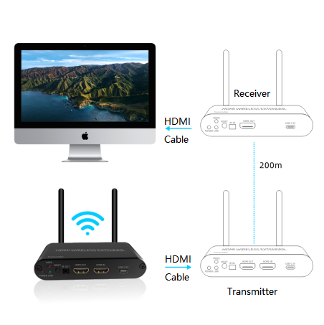

Port Definition

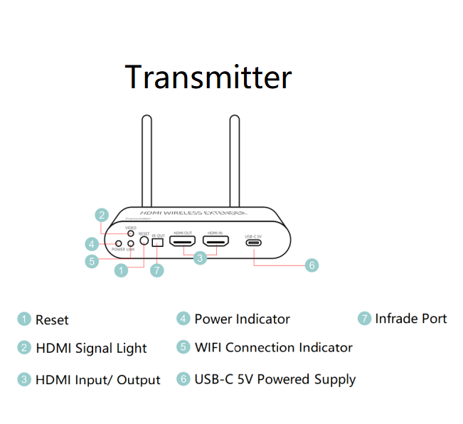
Port Definition

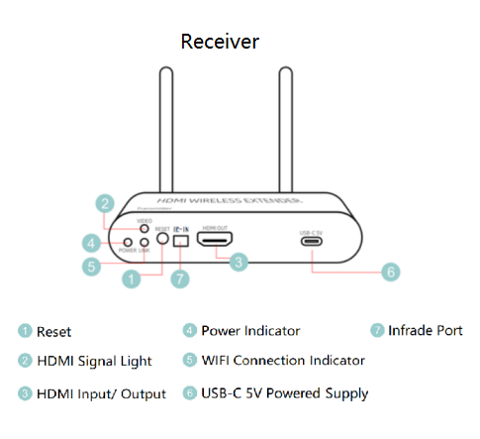

Steps for Usage
- Connect the Transmitter to the signal source by using a HDMI cable, and using a HDMI cable to connect the Receiver to the monitor or the TV. If the Receiver is connected to the TV, you should switch to the corresponding display resource. For example, you should switch it of TV to HDMI show.
- If loopout of theTransmitter is needed, then you need only to connect the HDMI Out Port ot it to your device by using a HDMI cable.
- If the infrared anti-control function is needed, then the transmitter should be connected to the infrared transmitting line , and the receiver should be connected to the infrared receiving line (There are marks on both transmitting line and receiving line).
- Connect to the power supply by using through the original adapter after preparation. It is forbidden to use other adapters. Generally speaking, it can work normally after powered by. Please refer to the page of exception handling when it can not work normally.
- After leaving the factory, it can work normally by default after being connected to the power supply to realize the wireless HDMI video transmission function. If you need to re-match, you can press the "reset" button on the transmitter and receiver at the same time for 5 seconds after the startup is complete and the waiting connection interface is displayed.

Exception Handling
- Power supply check. If the picture cannot be produced normally after powered on, please check whether the POWER light is on in the device. If not, please check whether it is plugged in properly.
- If the receiver keeps displaying the page of waiting for connection, please check whether the distance used exceeds the product’s capability, and it is recommended to use the test first without passing through the wall. If the waiting connection interface is still displayed after powering on for more than 2 times within the product’s capability, after the waiting connection interface is displayed, press the “Reset” button on both the transmitter and receiver at the same time for 5 seconds and release. Then check whether the waiting connection interface is no longer displayed, for example display waits for video source or works normally.
- If the receiver shows waiting for video source, check whether the HDMI signal source light is on and check whether the video source at the transmitter is plugged in. Or if the resolution exceeds 1080P, the resolution does not support 1080P and resolutions greater than 1080P.
- If the solutions above can’t solve your problem, please contact the customer service for after-sales processing.

Technical Support
Any problem while your useing, please contact us at +86 13392199271, or email us at support@liangtu-tech.com.
Web: www.liangtu-tech.com
WhatsApp: +86 133 9219 9271

